vII – ASSIGNMENT

1. Write a python program to remove a newline in python.

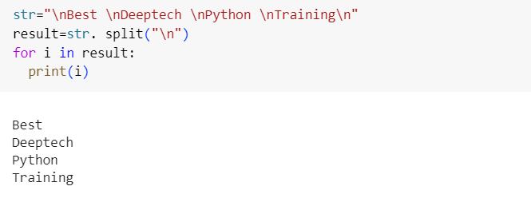

Output

Best

Deeptech

Python

Training

1. Write a python program to reverse words in a string.

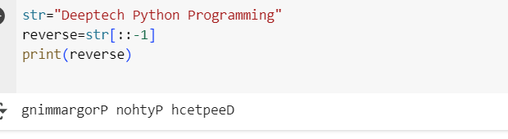

Output

gnimmargorp nohtyp hcetpeed